STASH
Database Schema Design
Revision 2.0 (with diagrams)
Scoped to Phase 1 (the consumer launch, v0.1 through v3.0). See the Stash Overall Product Document for the full phase and version roadmap. This schema documents the v1.0 launch state, with v1.5, v2.0, and v3.0 additions marked in their respective chapters.
A field-level reference for every entity in the Stash platform,
grouped by service, with relationships, indexes, and worked examples.
Companion to: Stash Overall Product Document, Stash Phases and Versions

0. How to Use This Document
This document is the canonical reference for every persistent entity in the Stash platform. If you are about to write a JPA entity, an SQL migration, a repository query, or any code that touches the database, this is the document you check first.
Stash is built as a modular monolith plus three extracted microservices: the Payments Service, the KYC Service, and the Audit Log Service. Each deployable owns its own PostgreSQL database, and within the monolith each module owns its own schema. Cross-schema and cross-service references are deliberate, named, and never expressed as SQL foreign keys across service boundaries.

Reading order
The chapters follow the architecture: platform first (auth, users, admin, notifications), then the financial modules that depend on platform identity (vault, susu, transfer, split), then social and expense, then the extracted services. The worked examples at the end show how the tables interact during real operations. Read the worked examples before writing your first persistence-layer code.

Each chapter contains
- A short orientation paragraph describing what the schema is for and how it fits the larger system.
- An ERD diagram showing the entities, their fields, and their relationships.
- Per-entity tables giving field name, type, key designation (PK/FK/UK), and constraints.
- Index recommendations beyond the obvious primary-key and unique-key indexes.
- Notes on subtle constraints, state transitions, and design decisions worth remembering.

Conventions used throughout
UUIDs everywhere. Every primary key is a UUID (specifically UUID v7 in the application layer, time-ordered for index locality). No serial/auto-increment integer IDs.
Money in pesewas. All money columns are BIGINT representing pesewas (1 Ghanaian cedi = 100 pesewas). Never DECIMAL, never FLOAT. The presentation layer formats cedis.
Times in UTC. All timestamps are TIMESTAMPTZ stored in UTC. Conversion to Ghana local time happens in the presentation layer.
Soft delete via deleted_at. User-facing entities use a deleted_at TIMESTAMPTZ column. NULL = active, non-NULL = deleted. Audit and ledger tables are append-only and never soft-deleted.
Cross-service references are logical, not physical. When the susu module references a user, it stores the user UUID but does NOT create a foreign key to user_module.users.id if the reference crosses a future service boundary. The doc notes which references are physical FKs and which are logical.
Append-only tables are enforced at the DB level. Ledger entries, outbox events, and audit log entries are append-only. A migration grants only INSERT/SELECT on these tables; UPDATE and DELETE are revoked from the application role.
Important
If you find yourself wanting to add a column to a table to handle a corner case, stop and ask in the team chat first. Schema changes ripple through migrations, JPA entities, DTOs, mappers, indexes, and queries. Adding 'just one column' is rarely just one column.

1. Platform: Identity & Sessions
The identity schemas hold the data that proves a person is who they say they are, that they have an active session with Stash, and that they are entitled to use the platform's features. These tables sit at the foundation: nearly every other table in the system references a user UUID either as a physical foreign key (when in the same service) or as a logical reference (when across service boundaries).
Two PostgreSQL schemas are involved: the auth schema, which holds refresh tokens (short-lived state used during authentication), and the user_module schema, which holds the user account itself plus the operational data tied to that account — email verification tokens and deletion requests.
The diagram below shows the four entities and their relationships. Note that auth.refresh_tokens references user_module.users via a physical foreign key — both schemas live inside the same monolith database, so the FK is enforced.
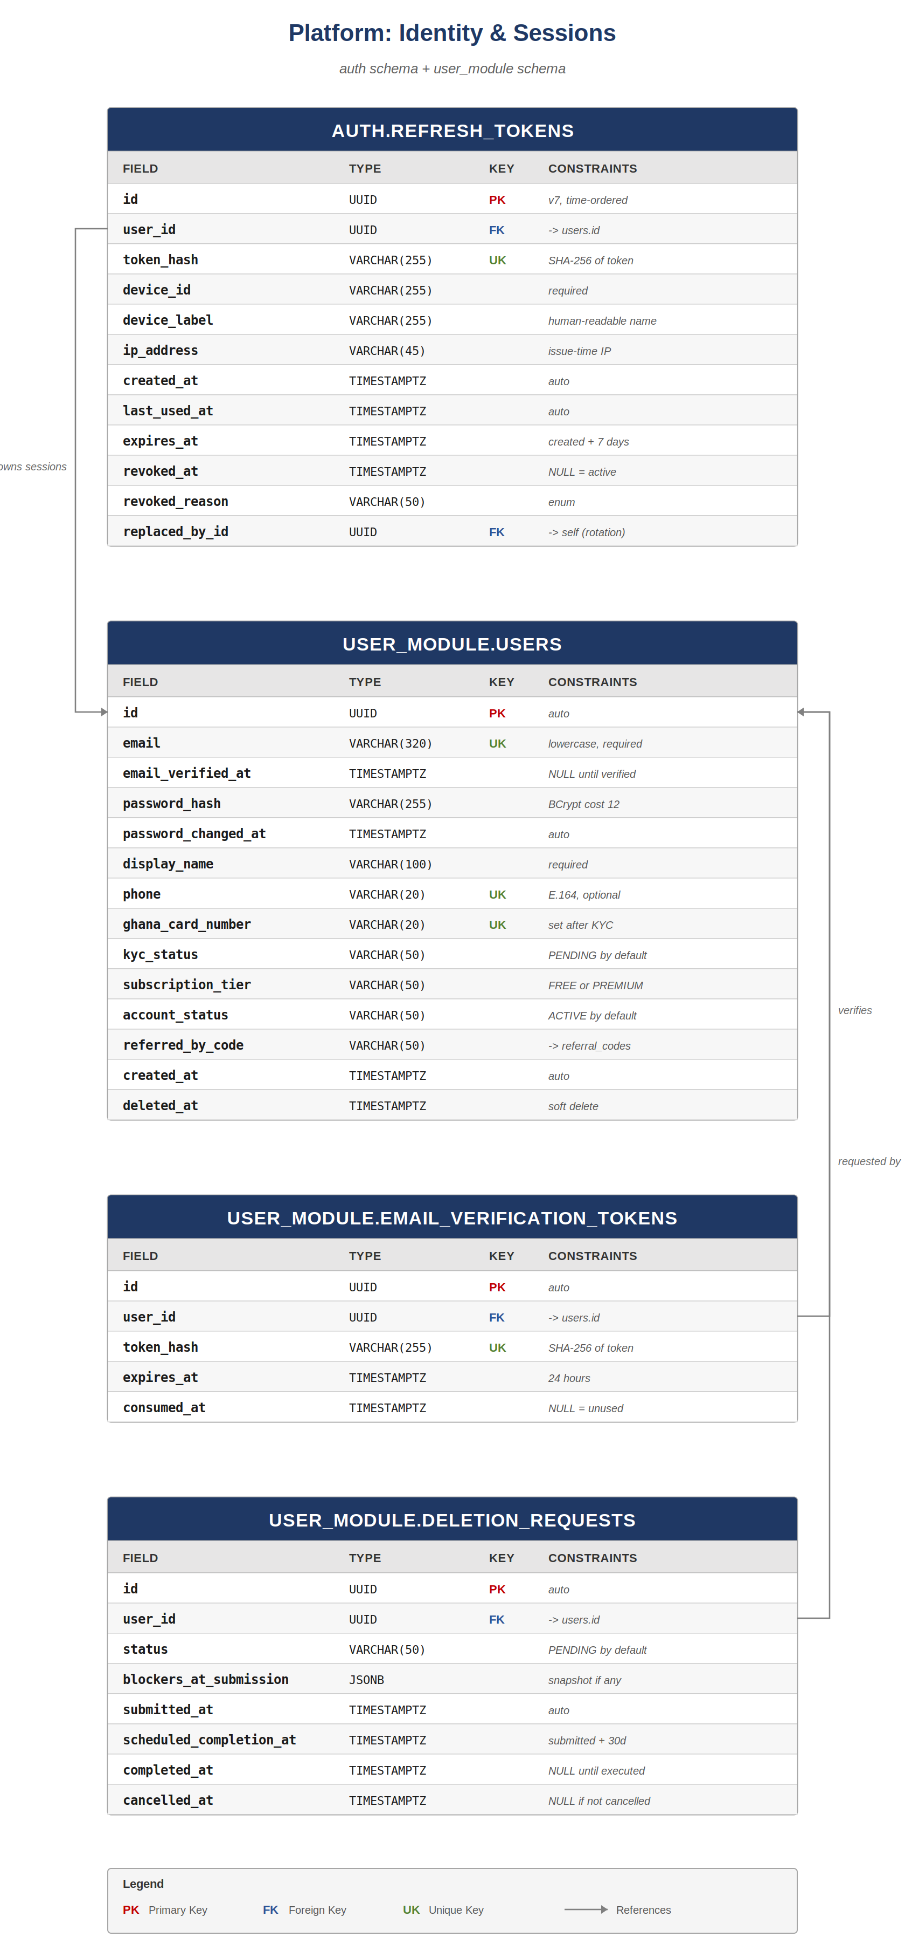

1.1 auth.refresh_tokens
Refresh tokens are the mechanism by which a logged-in client renews its short-lived access token without forcing the user to re-enter credentials. A token is created at login, hashed with SHA-256 before being stored, and rotates on every use. The rotation chain (via replaced_by_id) allows the security team to detect replay attacks: if a token that has already been rotated is presented again, the chain is followed and every descendant token is revoked.
Field | Type | Key | Constraints
id | UUID | PK | UUID v7, time-ordered for index locality
user_id | UUID | FK | References user_module.users(id), ON DELETE CASCADE
token_hash | VARCHAR(255) | UK | SHA-256 hex of the plaintext refresh token
device_id | VARCHAR(255) |  | Client-generated stable ID; required
device_label | VARCHAR(255) |  | Human-readable e.g. 'iPhone 13 Pro'
ip_address | VARCHAR(45) |  | IP at issue time (IPv6-capable length)
created_at | TIMESTAMPTZ |  | DEFAULT now()
last_used_at | TIMESTAMPTZ |  | Updated on every refresh exchange
expires_at | TIMESTAMPTZ |  | created_at + 7 days; absolute expiry
revoked_at | TIMESTAMPTZ |  | NULL = active; non-NULL = revoked
revoked_reason | VARCHAR(50) |  | Enum: USER_LOGOUT, ROTATION_REPLAY, ADMIN_FORCE, EXPIRED
replaced_by_id | UUID | FK | Self-reference; non-NULL after rotation

Indexes
- (user_id, revoked_at) — list active sessions for a user (the 'My Sessions' screen).
- (token_hash) — covered by the unique constraint; used at every refresh.
- (expires_at) WHERE revoked_at IS NULL — for the cleanup job that revokes expired tokens.

State transitions
A token is created with revoked_at NULL. On every successful refresh, a new token is created and the old token's revoked_at is set to now() and its replaced_by_id is set to the new token's id. If a rotated (revoked) token is presented again, the entire rotation chain is walked and every descendant is also revoked — that is the replay-attack response.

1.2 user_module.users
The canonical user record. One row per Stash account. Email and phone are unique; ghana_card_number becomes unique once KYC is approved. Soft delete via deleted_at; the deletion request flow (Section 1.4) governs when this is set.
Field | Type | Key | Constraints
id | UUID | PK | UUID v7
email | VARCHAR(320) | UK | Lowercased; required; RFC 5321 max length
email_verified_at | TIMESTAMPTZ |  | NULL until verification token consumed
password_hash | VARCHAR(255) |  | BCrypt hash, cost factor 12
password_changed_at | TIMESTAMPTZ |  | Used to invalidate older refresh tokens
display_name | VARCHAR(100) |  | Required; user-chosen
phone | VARCHAR(20) | UK | E.164; optional until certain features used
ghana_card_number | VARCHAR(20) | UK | Set only after KYC approval; CHECK length
kyc_status | VARCHAR(50) |  | PENDING/SUBMITTED/APPROVED/REJECTED; default PENDING
subscription_tier | VARCHAR(50) |  | FREE or PREMIUM; default FREE
account_status | VARCHAR(50) |  | ACTIVE/SUSPENDED/CLOSED; default ACTIVE
referred_by_code | VARCHAR(50) |  | Optional; references referral_codes.code
created_at | TIMESTAMPTZ |  | DEFAULT now()
deleted_at | TIMESTAMPTZ |  | NULL = active; soft delete

Indexes
- (email) — unique constraint, login lookups.
- (phone) WHERE phone IS NOT NULL — unique constraint.
- (ghana_card_number) WHERE ghana_card_number IS NOT NULL — unique constraint.
- (account_status) — operational queries; partial when ACTIVE is the common case is unnecessary since most rows will be ACTIVE.
- (kyc_status) — admin dashboard queries 'who has SUBMITTED waiting'.

Enums (CHECK constraints)
kyc_status | PENDING, SUBMITTED, APPROVED, REJECTED, RESUBMISSION_REQUIRED
subscription_tier | FREE, PREMIUM
account_status | ACTIVE, SUSPENDED, CLOSED

1.3 user_module.email_verification_tokens
A short-lived token sent to a user's email to prove email ownership. The token is hashed before storage (the plaintext only exists in the email and the URL the user clicks). Tokens expire after 24 hours and are single-use: once consumed_at is set, the token cannot be used again.
Field | Type | Key | Constraints
id | UUID | PK | auto
user_id | UUID | FK | -> users.id, ON DELETE CASCADE
token_hash | VARCHAR(255) | UK | SHA-256 hex of plaintext token
expires_at | TIMESTAMPTZ |  | created_at + 24 hours
consumed_at | TIMESTAMPTZ |  | NULL = unused, non-NULL = consumed

Index
- (user_id, consumed_at) — for resending checks ('is there an unused token already?').

1.4 user_module.deletion_requests
Account deletion in Stash is not immediate. A user submits a deletion request, the system snapshots any blockers (open susus, active locked vaults, outstanding splits), waits 30 days for cool-off, and then the actual deletion executes. During the 30 days, the user can cancel the request and resume normal usage.
Field | Type | Key | Constraints
id | UUID | PK | auto
user_id | UUID | FK | -> users.id
status | VARCHAR(50) |  | PENDING/COMPLETED/CANCELLED; default PENDING
blockers_at_submission | JSONB |  | snapshot of open susus/vaults/splits at request time
submitted_at | TIMESTAMPTZ |  | DEFAULT now()
scheduled_completion_at | TIMESTAMPTZ |  | submitted_at + 30 days
completed_at | TIMESTAMPTZ |  | NULL until the cleanup job runs
cancelled_at | TIMESTAMPTZ |  | NULL unless user cancels during cool-off

Indexes
- (scheduled_completion_at) WHERE status = 'PENDING' — for the daily cleanup job.
- (user_id) — for the 'my deletion request' screen.
Why the 30-day cool-off?
Deleting a user mid-susu would damage other members. The blockers snapshot proves what was open at submission. If a user wants to delete and has an open susu round, the request still submits, but the cool-off gives the susu time to complete before deletion executes. If during cool-off the user resolves the blockers and 30 days have passed, deletion proceeds. Otherwise the cleanup job logs the failure and the user remains in PENDING until blockers clear.

2. Platform: Admin & Notification
The admin schema holds the staff-side accounts that operate the platform: Super Admins, Vice Super Admins, and Tab Admins. Each admin action against a user or platform object is recorded immutably. The notification schema holds the outbound messages that go to users via push, email, or in-app delivery, plus the device tokens needed for push delivery.
There is a deliberate split between admin accounts and customer users — they are different tables in different schemas with different login flows. An admin never has a customer-facing user account on the same email; if a staff member also wants to use Stash as a customer, they create a separate user account.
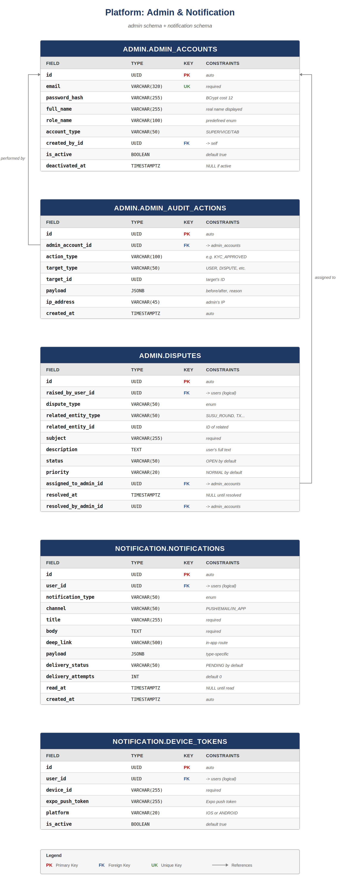

2.1 admin.admin_accounts
A single Super Admin row is created at bootstrap. The Super Admin can create Vice Super Admin accounts; Vice Super Admins can create Tab Admin accounts within their assigned tabs. The created_by_id self-reference encodes this hierarchy.
Field | Type | Key | Constraints
id | UUID | PK | auto
email | VARCHAR(320) | UK | Lowercased, required
password_hash | VARCHAR(255) |  | BCrypt cost 12
full_name | VARCHAR(255) |  | Real name (admin actions show real names)
role_name | VARCHAR(100) |  | Predefined: KYC_REVIEWER, DISPUTE_HANDLER, etc.
account_type | VARCHAR(50) |  | SUPER, VICE_SUPER, TAB
created_by_id | UUID | FK | -> admin_accounts.id; NULL only for original SUPER
is_active | BOOLEAN |  | DEFAULT true
deactivated_at | TIMESTAMPTZ |  | NULL if currently active

Indexes & constraints
- CHECK: exactly one row exists with account_type = 'SUPER' (partial unique index).
- (email) — unique.
- (account_type, is_active) — for staff directory views.

2.2 admin.admin_audit_actions
Every action a staff member takes against the platform is logged here. The payload column stores the before/after state and any reason text. This is a write-once table at the application level; the actual append-only enforcement happens in the Audit Log Service (Chapter 9), but a local copy lives here for the admin dashboard's recent activity view to remain fast even when the audit service is unreachable.
Field | Type | Key | Constraints
id | UUID | PK | auto
admin_account_id | UUID | FK | -> admin_accounts.id
action_type | VARCHAR(100) |  | e.g. KYC_APPROVED, USER_SUSPENDED, REFUND_ISSUED
target_type | VARCHAR(50) |  | USER, DISPUTE, SUSU_GROUP, VAULT, etc.
target_id | UUID |  | ID of the affected entity
payload | JSONB |  | { before, after, reason }
ip_address | VARCHAR(45) |  | Admin's IP at action time
created_at | TIMESTAMPTZ |  | DEFAULT now()

Indexes
- (admin_account_id, created_at DESC) — 'recent actions by this admin'.
- (target_type, target_id, created_at DESC) — 'history of actions on this entity'.
- (action_type, created_at DESC) — 'all KYC approvals this week'.

2.3 admin.disputes
Users can raise disputes about specific platform actions: a susu round they think was miscalculated, a transfer they didn't authorise, a KYC rejection they want appealed. Disputes flow through OPEN -> IN_REVIEW -> RESOLVED. The related_entity_type and related_entity_id form a polymorphic reference; no FK is set because the related entity may live in another service.
Field | Type | Key | Constraints
id | UUID | PK | auto
raised_by_user_id | UUID | FK | -> users.id (logical, but in same DB)
dispute_type | VARCHAR(50) |  | TRANSACTION/KYC/SUSU/OTHER
related_entity_type | VARCHAR(50) |  | Polymorphic: SUSU_ROUND, TRANSACTION, KYC_SUBMISSION...
related_entity_id | UUID |  | ID of the related thing
subject | VARCHAR(255) |  | Required, user-facing
description | TEXT |  | User's full text
status | VARCHAR(50) |  | OPEN, IN_REVIEW, RESOLVED, CLOSED_NO_ACTION
priority | VARCHAR(20) |  | LOW, NORMAL, HIGH, CRITICAL
assigned_to_admin_id | UUID | FK | -> admin_accounts.id; NULL if unassigned
resolved_at | TIMESTAMPTZ |  | NULL until resolved
resolved_by_admin_id | UUID | FK | -> admin_accounts.id

2.4 notification.notifications
Every outbound notification has a row here. The row is created in PENDING status, then a background worker picks it up, dispatches to the appropriate channel (Expo push, Resend email, in-app inbox only), and updates delivery_status. The notifications table doubles as the in-app inbox: 'IN_APP' channel notifications are simply displayed by querying this table where the user is the recipient.
Field | Type | Key | Constraints
id | UUID | PK | auto
user_id | UUID | FK | -> users.id
notification_type | VARCHAR(50) |  | Enum (see below)
channel | VARCHAR(50) |  | PUSH, EMAIL, IN_APP
title | VARCHAR(255) |  | Required
body | TEXT |  | Required
deep_link | VARCHAR(500) |  | In-app route to navigate to on tap
payload | JSONB |  | Type-specific extras
delivery_status | VARCHAR(50) |  | PENDING/DELIVERED/FAILED/SUPPRESSED
delivery_attempts | INT |  | DEFAULT 0; capped at 3
read_at | TIMESTAMPTZ |  | NULL until user reads (in-app only)
created_at | TIMESTAMPTZ |  | DEFAULT now()

Common notification types
DEPOSIT_SUCCESS | Vault deposit completed
WITHDRAWAL_SUCCESS | Vault withdrawal completed
SUSU_CONTRIBUTION_DUE | Reminder for upcoming susu contribution
SUSU_PAYOUT_RECEIVED | Your susu round paid out
KYC_APPROVED | KYC verification succeeded
KYC_REJECTED | KYC verification needs attention
TRANSFER_RECEIVED | Peer transfer credited
LOCKED_VAULT_EARLY_EXIT_REQUESTED | Cool-off countdown started
SPLIT_PAYMENT_DUE | A split you're in needs your share

2.5 notification.device_tokens
Each user may have multiple devices, and each device has one Expo push token at a time. When a user reinstalls or moves to a new device, a new row is added; the old row's is_active is flipped to false. The notification worker pushes to every is_active = true row for the user.
Field | Type | Key | Constraints
id | UUID | PK | auto
user_id | UUID | FK | -> users.id
device_id | VARCHAR(255) |  | Required, stable per device
expo_push_token | VARCHAR(255) |  | Issued by Expo at app install
platform | VARCHAR(20) |  | IOS or ANDROID
is_active | BOOLEAN |  | DEFAULT true

Indexes
- (user_id, is_active) WHERE is_active = true — for push dispatch.
- (user_id, device_id) — unique; one active token per device.

3. Financial: Vault & Susu
Vaults and susus are Stash's two flagship saving mechanisms. A vault is an individual saving pocket — STANDARD vaults are flexible (deposit and withdraw at will), LOCKED vaults are committed (cannot withdraw until an unlock condition is met). A susu is a rotating-savings group where members each contribute a fixed amount per round, and one member receives the pot each round in a pre-agreed rotation.
Both mechanisms hold real money, so both depend critically on the Payments Service (Chapters 6 and 7). Money never lives in vault.vaults itself — only the vault's identity and configuration do. The balance lives in a corresponding ledger_account inside the Payments Service. The same applies to susus: the susu_groups table holds membership and rules, but the pot itself is a ledger account.
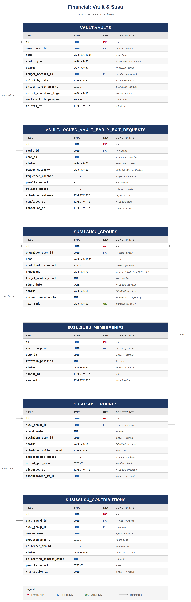

3.1 vault.vaults
One row per vault. Each vault is owned by exactly one user and has its own ledger account. Vault type determines the unlock semantics: STANDARD has no lock and unlock columns are NULL; LOCKED has at least one unlock condition (date, target amount, or both) and unlock_condition_logic = AND/OR.
Field | Type | Key | Constraints
id | UUID | PK | auto
owner_user_id | UUID | FK | -> users.id (logical reference if vault module is in monolith with user module, can be physical)
name | VARCHAR(100) |  | User-chosen
vault_type | VARCHAR(20) |  | STANDARD or LOCKED
status | VARCHAR(50) |  | ACTIVE/LOCKED/EARLY_EXIT_PENDING/CLOSED
ledger_account_id | UUID |  | Logical FK -> ledger.ledger_accounts (cross-service)
unlock_by_date | TIMESTAMPTZ |  | If LOCKED + date-based
unlock_target_amount | BIGINT |  | If LOCKED + amount-based (pesewas)
unlock_condition_logic | VARCHAR(10) |  | AND or OR (only if both unlock columns set)
early_exit_in_progress | BOOLEAN |  | DEFAULT false; flipped during cool-off
created_at | TIMESTAMPTZ |  | DEFAULT now()
deleted_at | TIMESTAMPTZ |  | Soft delete

Constraints
- CHECK: vault_type = 'STANDARD' AND unlock_by_date IS NULL AND unlock_target_amount IS NULL, OR vault_type = 'LOCKED' AND at least one unlock column is set.
- CHECK: if both unlock_by_date and unlock_target_amount are set, unlock_condition_logic must be set.

Indexes
- (owner_user_id, deleted_at) — 'list my vaults'.
- (status) — operational queries.

3.2 vault.locked_vault_early_exit_requests
When a user wants to break a locked vault early, they file a request here. The request enters a 72-hour cool-off during which the user can cancel without penalty. If the cool-off expires, the vault is force-unlocked: a 5% penalty is applied, and the remaining balance is released to the user's USER_WALLET ledger account.
Field | Type | Key | Constraints
id | UUID | PK | auto
vault_id | UUID | FK | -> vaults.id
user_id | UUID |  | Vault owner snapshot (for cross-service audit)
status | VARCHAR(50) |  | PENDING/COMPLETED/CANCELLED
reason_category | VARCHAR(50) |  | EMERGENCY/IMPULSE/OTHER (user-selected)
requested_balance | BIGINT |  | Vault balance snapshot at request
penalty_amount | BIGINT |  | 5% of requested_balance
release_amount | BIGINT |  | requested_balance - penalty_amount
scheduled_release_at | TIMESTAMPTZ |  | submitted + 72 hours
completed_at | TIMESTAMPTZ |  | NULL until released
cancelled_at | TIMESTAMPTZ |  | NULL unless cancelled during cool-off
Why snapshot the balance?
Between the request and the release, the user could in theory deposit more to the vault. The penalty is calculated on the balance at request time, not at release time. If new deposits arrive during cool-off, they pass through to release at 100% (no penalty on the new amount). This is enforced by the release logic, not by blocking deposits.

3.3 susu.susu_groups
A susu group is created in PENDING state with target_member_count, contribution_amount, and frequency set. The organiser invites members, who join via join_code. Once target_member_count is reached, the organiser activates the group: status flips to ACTIVE, start_date is set, and the system eagerly generates one susu_rounds row per member with rotation positions assigned (the order is the order members joined, with the organiser at position 1).
Field | Type | Key | Constraints
id | UUID | PK | auto
organiser_user_id | UUID | FK | -> users.id
name | VARCHAR(100) |  | Required
contribution_amount | BIGINT |  | Pesewas; per member per round
frequency | VARCHAR(20) |  | WEEKLY/BIWEEKLY/MONTHLY
target_member_count | INT |  | 2-20 members
start_date | DATE |  | NULL until activated
status | VARCHAR(50) |  | PENDING/ACTIVE/COMPLETED/CANCELLED
current_round_number | INT |  | 1-based; NULL until activated
join_code | VARCHAR(20) | UK | Members enter to join
created_at | TIMESTAMPTZ |  | DEFAULT now()

3.4 susu.susu_memberships
One row per member per group. rotation_position is assigned at activation, in join order, and never changes afterwards — members joining late are not permitted, and a member leaving mid-cycle marks their membership as REMOVED but does not collapse the positions (their position rounds are reassigned to a substitute if one is approved by remaining members, otherwise the round is skipped).
Field | Type | Key | Constraints
id | UUID | PK | auto
susu_group_id | UUID | FK | -> susu_groups.id
user_id | UUID |  | logical -> users.id
rotation_position | INT |  | 1-based, unique per group, set at activation
status | VARCHAR(50) |  | ACTIVE, REMOVED, COMPLETED
joined_at | TIMESTAMPTZ |  | DEFAULT now()
removed_at | TIMESTAMPTZ |  | NULL if currently active

Constraints
- UNIQUE (susu_group_id, user_id) — a user can only be in a group once.
- UNIQUE (susu_group_id, rotation_position) WHERE status = 'ACTIVE' — no two active members at the same position.

3.5 susu.susu_rounds
Rounds are generated eagerly when a susu group is activated — one row per member, in rotation order. Each round has a status that progresses PENDING -> COLLECTING -> DISBURSED -> COMPLETED. The disbursement_transaction_id (logical) ties the round to the payout transaction in the Payments Service once the pot is paid out.
Field | Type | Key | Constraints
id | UUID | PK | auto
susu_group_id | UUID | FK | -> susu_groups.id
round_number | INT |  | 1-based, sequential within group
recipient_user_id | UUID |  | Member receiving this round's pot
status | VARCHAR(50) |  | PENDING/COLLECTING/DISBURSED/COMPLETED/SKIPPED
scheduled_collection_at | TIMESTAMPTZ |  | When contributions are due
expected_pot_amount | BIGINT |  | contribution_amount × member_count
actual_pot_amount | BIGINT |  | Set after collection closes
disbursed_at | TIMESTAMPTZ |  | NULL until paid out
disbursement_transaction_id | UUID |  | Logical -> transaction record

3.6 susu.susu_contributions
One row per member per round. Created when the round enters COLLECTING. The contribution flows from the member's USER_WALLET to the susu group's SUSU_POT ledger account. Late contributions accrue a penalty (configurable per group at v2.0; flat per-group at v1.0) which is tracked here and deducted from that member's eventual payout when their turn comes.
Field | Type | Key | Constraints
id | UUID | PK | auto
susu_round_id | UUID | FK | -> susu_rounds.id
susu_group_id | UUID | FK | Denormalized for fast per-group queries
member_user_id | UUID |  | logical -> users.id
expected_amount | BIGINT |  | Same as group's contribution_amount at round creation
collected_amount | BIGINT |  | Amount actually collected
status | VARCHAR(50) |  | PENDING/PAID/LATE/MISSED
collection_attempt_count | INT |  | DEFAULT 0
penalty_amount | BIGINT |  | DEFAULT 0; accumulates if LATE
transaction_id | UUID |  | logical -> payment transaction

4. Financial: Transfer & Split
Peer-to-peer transfers move money from one user's wallet to another's. Split payments handle the case where one person fronts the cost (e.g. a restaurant bill) and several people owe their share. Both modules sit on top of the ledger primitives in the Payments Service.
The transfer module ships at v1.0; the split module ships at v1.5 once the core transfer mechanism is stable. The diagram below shows both for completeness, but the split tables will not exist in the v1.0 schema.
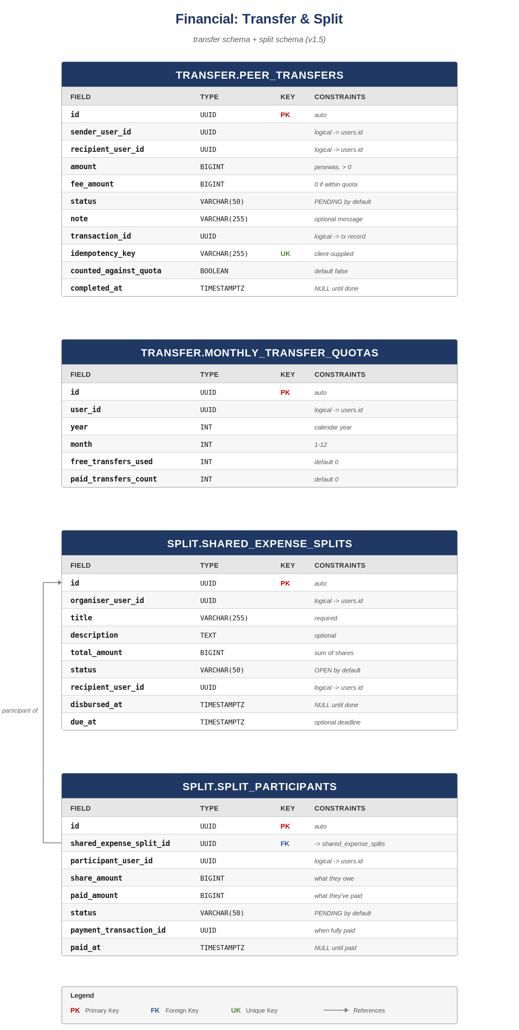

4.1 transfer.peer_transfers
Each peer transfer is a single row representing one user sending money to another. The transfer is created in PENDING, validated for sufficient balance and recipient eligibility, then completed by writing a ledger transaction. Each user gets a quota of free transfers per calendar month (currently 5); beyond the quota, a small fixed fee is charged.
Field | Type | Key | Constraints
id | UUID | PK | auto
sender_user_id | UUID |  | logical -> users.id
recipient_user_id | UUID |  | logical -> users.id
amount | BIGINT |  | Pesewas; CHECK > 0
fee_amount | BIGINT |  | 0 if within free quota
status | VARCHAR(50) |  | PENDING/COMPLETED/FAILED
note | VARCHAR(255) |  | Optional message
transaction_id | UUID |  | logical -> payment transaction
idempotency_key | VARCHAR(255) | UK | Client-supplied UUID
counted_against_free_quota | BOOLEAN |  | DEFAULT false; set true on COMPLETED if free-quota transfer
completed_at | TIMESTAMPTZ |  | NULL until terminal
created_at | TIMESTAMPTZ |  | DEFAULT now()

Indexes
- (sender_user_id, created_at DESC) — 'my sent transfers'.
- (recipient_user_id, created_at DESC) — 'my received transfers'.
- (idempotency_key) — covered by unique constraint.

4.2 transfer.monthly_transfer_quotas
Tracks each user's per-month transfer quota usage. One row per user per month, created lazily when the user first transfers in that month. The check at transfer time is: 'is free_transfers_used < FREE_QUOTA_LIMIT?' — if yes, the transfer is free and free_transfers_used increments on completion; if no, fee_amount is set on the peer_transfer.
Field | Type | Key | Constraints
id | UUID | PK | auto
user_id | UUID |  | logical -> users.id
year | INT |  | Calendar year
month | INT |  | 1-12
free_transfers_used | INT |  | DEFAULT 0
paid_transfers_count | INT |  | DEFAULT 0

Constraint
- UNIQUE (user_id, year, month).

4.3 split.shared_expense_splits (v1.5)
The split itself: who organised it, how much it totals, who eventually receives the consolidated payment (usually the organiser, but configurable). Status moves OPEN -> PARTIALLY_PAID -> COMPLETED, or COMPLETED -> CANCELLED if the organiser cancels mid-flow (any partial payments are refunded).
Field | Type | Key | Constraints
id | UUID | PK | auto
organiser_user_id | UUID |  | logical -> users.id
title | VARCHAR(255) |  | Required
description | TEXT |  | Optional
total_amount | BIGINT |  | Sum of all participant shares
status | VARCHAR(50) |  | OPEN/PARTIALLY_PAID/COMPLETED/CANCELLED
recipient_user_id | UUID |  | Who gets the consolidated payment
disbursed_at | TIMESTAMPTZ |  | NULL until recipient is paid out
due_at | TIMESTAMPTZ |  | Optional soft deadline for participants
created_at | TIMESTAMPTZ |  | DEFAULT now()

4.4 split.split_participants (v1.5)
One row per person who owes a share. share_amount is what they owe; paid_amount tracks partial payments (a participant can pay in pieces). status moves PENDING -> PAID. When every participant is PAID, the split's status flips to COMPLETED and the consolidated payout to recipient_user_id is triggered.
Field | Type | Key | Constraints
id | UUID | PK | auto
shared_expense_split_id | UUID | FK | -> shared_expense_splits.id
participant_user_id | UUID |  | logical -> users.id
share_amount | BIGINT |  | What this participant owes
paid_amount | BIGINT |  | Running total of partial payments
status | VARCHAR(50) |  | PENDING/PARTIALLY_PAID/PAID
payment_transaction_id | UUID |  | Set when fully paid
paid_at | TIMESTAMPTZ |  | NULL until fully paid

5. Social & Expense Tracking
The challenge module gives users savings goals (system-defined in v1.0; user-created in v1.5) and badges for completion. The expense module ships in v2.0 and gives users a tool for tracking spending by category against monthly budgets — it lives entirely within the Stash app but does not touch the ledger, since expenses tracked here are typically out-of-app (groceries, transport) rather than Stash-internal transactions.
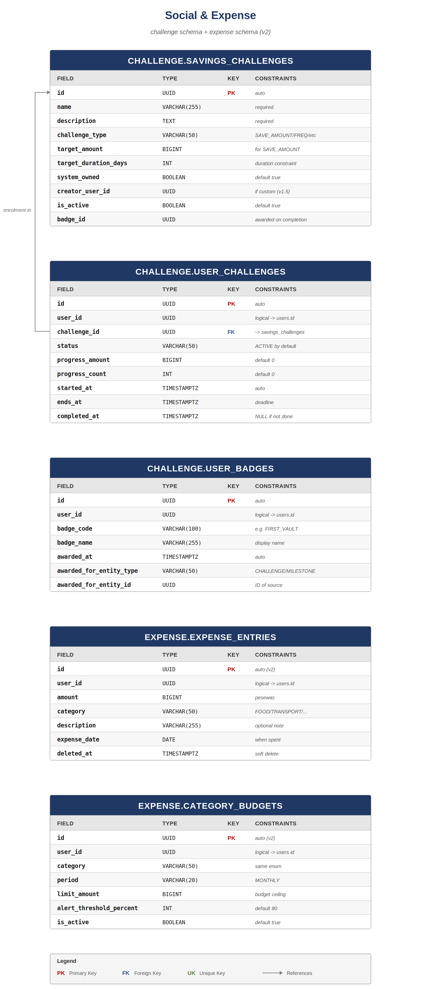

5.1 challenge.savings_challenges
Predefined challenge templates. In v1.0 only system-owned challenges exist (system_owned = true, creator_user_id NULL). In v1.5 users may create custom challenges (system_owned = false). Each completed challenge can award a badge by setting badge_id.
Field | Type | Key | Constraints
id | UUID | PK | auto
name | VARCHAR(255) |  | Required
description | TEXT |  | Required
challenge_type | VARCHAR(50) |  | SAVE_AMOUNT, SAVE_FREQUENCY, STREAK, NO_WITHDRAWAL
target_amount | BIGINT |  | For SAVE_AMOUNT
target_duration_days | INT |  | Duration constraint
system_owned | BOOLEAN |  | DEFAULT true
creator_user_id | UUID |  | NULL if system_owned
is_active | BOOLEAN |  | DEFAULT true
badge_id | UUID |  | Awarded on completion

5.2 challenge.user_challenges
When a user joins a challenge, a row is created here. Progress is updated by events from the vault module — every deposit increments progress_amount for ACTIVE challenges of type SAVE_AMOUNT belonging to that user. When progress reaches target, completed_at is set and any associated badge is awarded.
Field | Type | Key | Constraints
id | UUID | PK | auto
user_id | UUID |  | logical -> users.id
challenge_id | UUID | FK | -> savings_challenges.id
status | VARCHAR(50) |  | ACTIVE/COMPLETED/FAILED/ABANDONED
progress_amount | BIGINT |  | DEFAULT 0
progress_count | INT |  | DEFAULT 0 (for frequency challenges)
started_at | TIMESTAMPTZ |  | DEFAULT now()
ends_at | TIMESTAMPTZ |  | Deadline; failure if ACTIVE past this
completed_at | TIMESTAMPTZ |  | NULL until success

5.3 challenge.user_badges
Award log. Each row is a single award event: a specific user earning a specific badge from a specific source (a challenge completion, a milestone reached, an admin-issued grant).
Field | Type | Key | Constraints
id | UUID | PK | auto
user_id | UUID |  | logical -> users.id
badge_code | VARCHAR(100) |  | e.g. FIRST_VAULT, 10K_SAVED, NO_BREAK_30D
badge_name | VARCHAR(255) |  | Display name shown to user
awarded_at | TIMESTAMPTZ |  | DEFAULT now()
awarded_for_entity_type | VARCHAR(50) |  | CHALLENGE/MILESTONE/MANUAL
awarded_for_entity_id | UUID |  | ID of the trigger entity

5.4 expense.expense_entries (v2.0)
Manual expense entries. The user types in 'spent 25 cedis on lunch' and the row is created with category = FOOD and expense_date set. No money moves; this is pure self-tracking. The expense module exists to give users visibility into out-of-app spending alongside their in-app savings.
Field | Type | Key | Constraints
id | UUID | PK | auto
user_id | UUID |  | logical -> users.id
amount | BIGINT |  | Pesewas; CHECK > 0
category | VARCHAR(50) |  | Enum (FOOD/TRANSPORT/UTILITIES/...)
description | VARCHAR(255) |  | Optional note
expense_date | DATE |  | When the spending happened
created_at | TIMESTAMPTZ |  | DEFAULT now()
deleted_at | TIMESTAMPTZ |  | Soft delete

5.5 expense.category_budgets (v2.0)
Per-category monthly budget. When the user sets 'I want to spend at most 500 cedis on food this month', a row is created here. When expense_entries roll up to within alert_threshold_percent of limit_amount, an in-app notification is generated.
Field | Type | Key | Constraints
id | UUID | PK | auto
user_id | UUID |  | logical -> users.id
category | VARCHAR(50) |  | Same enum as expense_entries.category
period | VARCHAR(20) |  | MONTHLY (only option in v2.0)
limit_amount | BIGINT |  | Pesewas; budget ceiling
alert_threshold_percent | INT |  | DEFAULT 80; trigger alert at this %
is_active | BOOLEAN |  | DEFAULT true

6. Payments Service: Ledger & Transactions
The Payments Service is the only place real money is tracked. Every other module that 'holds money' (vaults, susus, splits, transfers) does so by holding a reference to a ledger_account inside this service. The ledger is double-entry: every transaction has two or more entries that sum to zero — for every debit there is a balancing credit.
This chapter covers the four core tables of the Payments Service: ledger_accounts (the books), ledger_transactions (the events that update them), ledger_entries (the immutable individual debits and credits), and transactions (the customer-facing transaction record that wraps a ledger transaction). The infrastructure tables — idempotency, outbox, webhook, paystack subaccounts — are covered in Chapter 7.
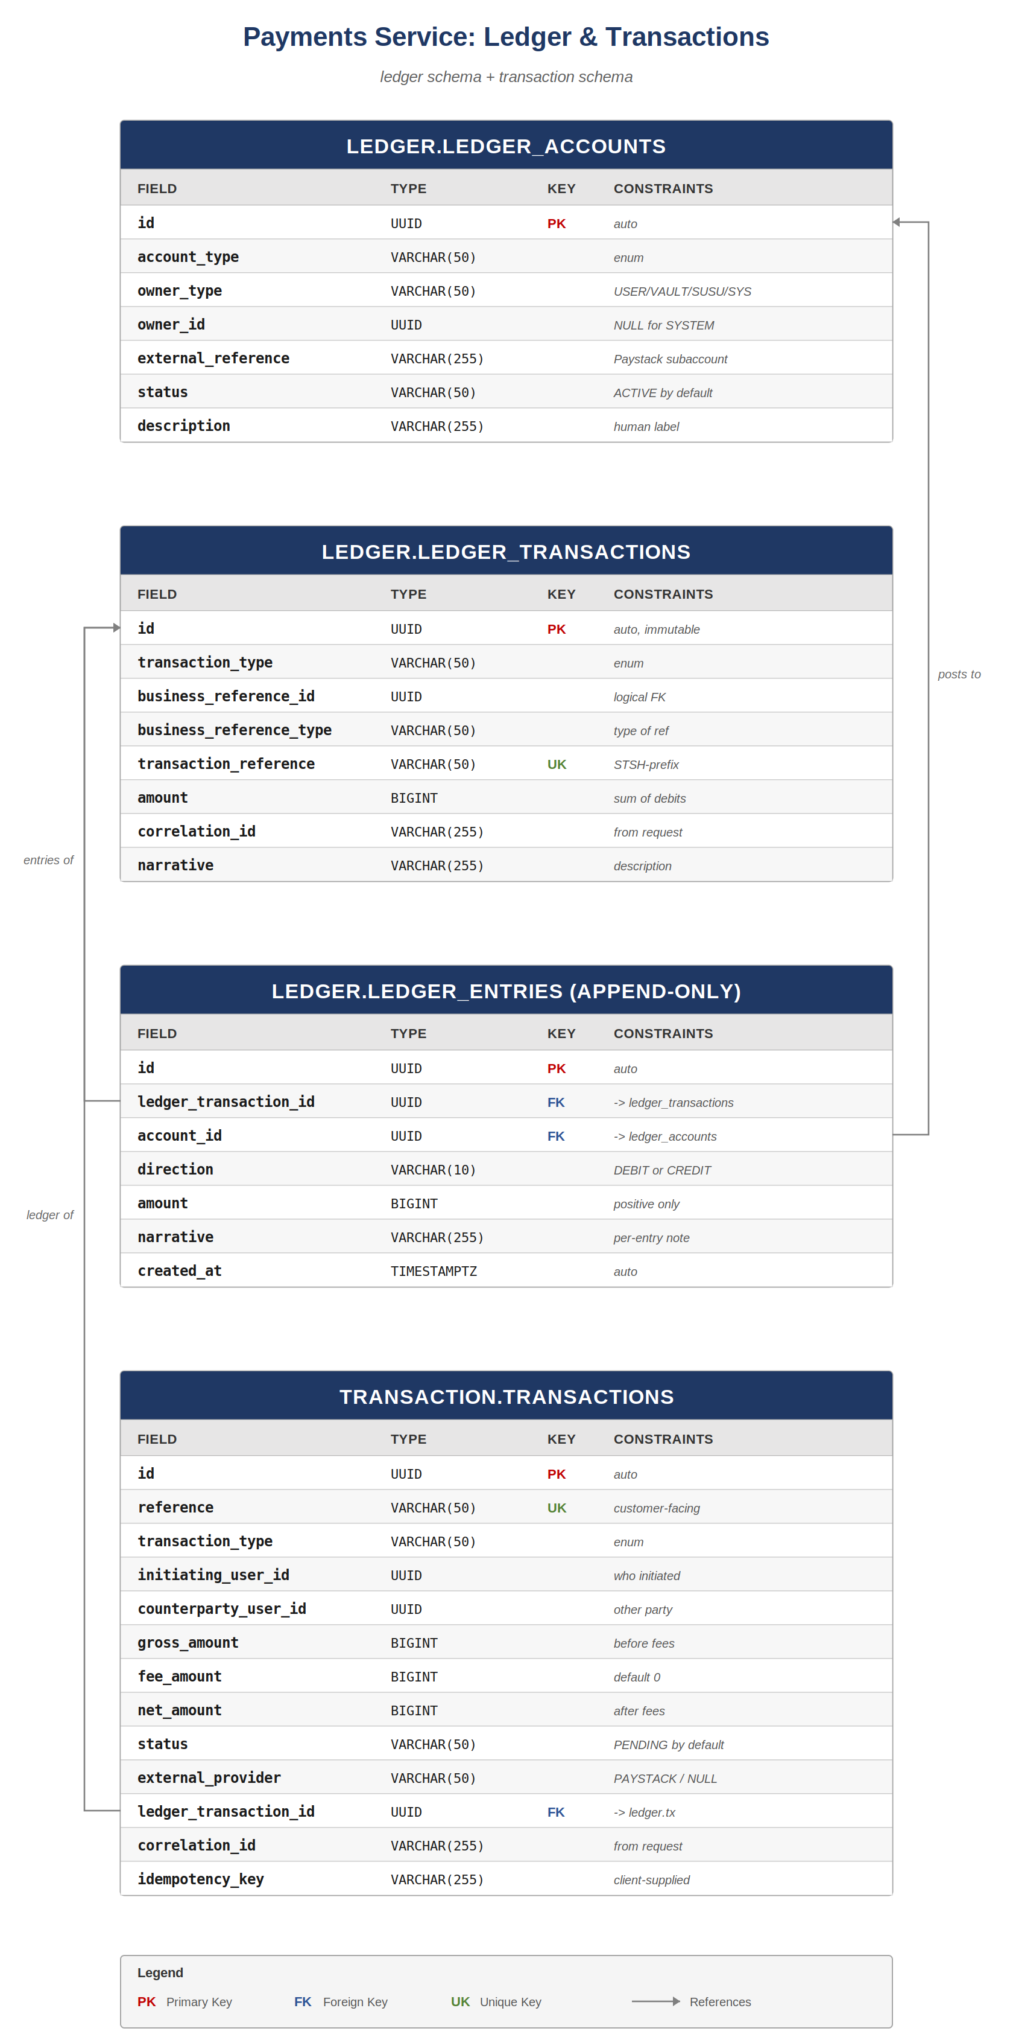

6.1 ledger.ledger_accounts
Every 'pocket' of money is a row here. A user's wallet is one account; each of their vaults is its own account; each susu group's pot is one account; and the system has several special accounts (FEE_REVENUE, PENALTY_REVENUE, PAYSTACK_SETTLEMENT, etc.). An account has an implicit balance computed as the sum of credits minus the sum of debits of its ledger_entries; the application caches the balance for fast reads (out of scope for this schema doc — see Caching Strategy in the Module Boundaries doc).
Field | Type | Key | Constraints
id | UUID | PK | auto
account_type | VARCHAR(50) |  | USER_WALLET, VAULT, SUSU_POT, FEE_REVENUE, ...
owner_type | VARCHAR(50) |  | USER/VAULT/SUSU_GROUP/SYSTEM
owner_id | UUID |  | NULL for SYSTEM accounts
external_reference | VARCHAR(255) |  | e.g. Paystack subaccount code
status | VARCHAR(50) |  | ACTIVE/FROZEN/CLOSED
description | VARCHAR(255) |  | Human-readable label for admins
created_at | TIMESTAMPTZ |  | DEFAULT now()

Indexes
- (owner_type, owner_id) — find the account for a given entity.
- (account_type, status) — operational queries.
- UNIQUE (owner_type, owner_id, account_type) — exactly one account of a given type per owner.

6.2 ledger.ledger_transactions
An atomic, immutable accounting event. A ledger_transaction groups together the entries that change account balances. Once written, the row is never updated or deleted: the ledger is append-only at the entries table level (Section 6.3), and ledger_transactions are conceptually append-only too (no UPDATE granted on this table either).
Field | Type | Key | Constraints
id | UUID | PK | auto
transaction_type | VARCHAR(50) |  | DEPOSIT/WITHDRAWAL/TRANSFER/SUSU_CONTRIBUTION/...
business_reference_id | UUID |  | Logical FK to whatever business object triggered this
business_reference_type | VARCHAR(50) |  | Type of business reference (TRANSFER, VAULT_DEPOSIT, ...)
transaction_reference | VARCHAR(50) | UK | Customer-facing reference; STSH-yyyymm-XXXXXX
amount | BIGINT |  | Sum of debits = sum of credits
correlation_id | VARCHAR(255) |  | From the originating request
narrative | VARCHAR(255) |  | Human description for ops/support
created_at | TIMESTAMPTZ |  | DEFAULT now()

6.3 ledger.ledger_entries (APPEND-ONLY)
The individual debits and credits that make up a transaction. Each row decreases one account (DEBIT) or increases one account (CREDIT) by a positive amount. Two database-level protections: every entry has its created_at automatically set and never updated, and the application role is granted only INSERT and SELECT on this table — UPDATE and DELETE are revoked. The migration that creates this table includes the REVOKE statements.
Field | Type | Key | Constraints
id | UUID | PK | auto
ledger_transaction_id | UUID | FK | -> ledger_transactions.id; the txn this entry belongs to
account_id | UUID | FK | -> ledger_accounts.id; the account affected
direction | VARCHAR(10) |  | DEBIT or CREDIT
amount | BIGINT |  | CHECK > 0; the magnitude
narrative | VARCHAR(255) |  | Optional per-entry note
created_at | TIMESTAMPTZ |  | DEFAULT now()

Indexes
- (account_id, created_at DESC) — account statement queries.
- (ledger_transaction_id) — fetch all entries for a transaction.
Double-entry invariant
For every ledger_transaction, the sum of entries where direction='DEBIT' MUST equal the sum of entries where direction='CREDIT'. This invariant is enforced at the application layer when entries are written; a recurring verification job re-checks it overnight and alerts on any drift. The invariant is what makes accidental money creation or destruction impossible.

6.4 transaction.transactions
The customer-facing transaction record. Every operation that touches money creates one transaction row here. transactions wraps ledger_transactions and adds the things the customer cares about: a reference they can quote to support, who the counterparty was, fees vs gross vs net amounts, the external provider (Paystack) if any, and the original idempotency key from the client request.
Field | Type | Key | Constraints
id | UUID | PK | auto
reference | VARCHAR(50) | UK | Customer-visible; STSH-yyyymm-XXXXXX
transaction_type | VARCHAR(50) |  | DEPOSIT/WITHDRAWAL/TRANSFER/...
initiating_user_id | UUID |  | Who triggered this
counterparty_user_id | UUID |  | Other party (NULL for self-only operations)
gross_amount | BIGINT |  | Before fees
fee_amount | BIGINT |  | DEFAULT 0
net_amount | BIGINT |  | gross - fee
status | VARCHAR(50) |  | PENDING/COMPLETED/FAILED/REVERSED
external_provider | VARCHAR(50) |  | PAYSTACK or NULL (internal-only)
ledger_transaction_id | UUID | FK | -> ledger.ledger_transactions
correlation_id | VARCHAR(255) |  | From request
idempotency_key | VARCHAR(255) |  | From client request
created_at | TIMESTAMPTZ |  | DEFAULT now()
completed_at | TIMESTAMPTZ |  | NULL until terminal status

Indexes
- (reference) — covered by unique constraint; support lookups.
- (initiating_user_id, created_at DESC) — 'my transactions' screen.
- (idempotency_key) WHERE idempotency_key IS NOT NULL — replay detection.
- (status) WHERE status = 'PENDING' — for the stuck-transaction monitor.

7. Payments Service: Infrastructure
Four supporting tables make the Payments Service safe under real-world conditions: idempotency_keys (so retries don't double-charge), outbox_events (so events to other services don't get lost), processed_webhook_events (so Paystack webhooks are processed at-most-once), and paystack_sub_accounts (linking our ledger to Paystack's accounts).
These are the tables that prevent the disasters. If a user taps 'deposit' twice because the network was slow, idempotency_keys ensures only one deposit happens. If the susu module needs to know a contribution succeeded, outbox_events ensures the event is delivered eventually even if RabbitMQ is down at write time. If Paystack retries a webhook, processed_webhook_events ensures the second delivery is a no-op.
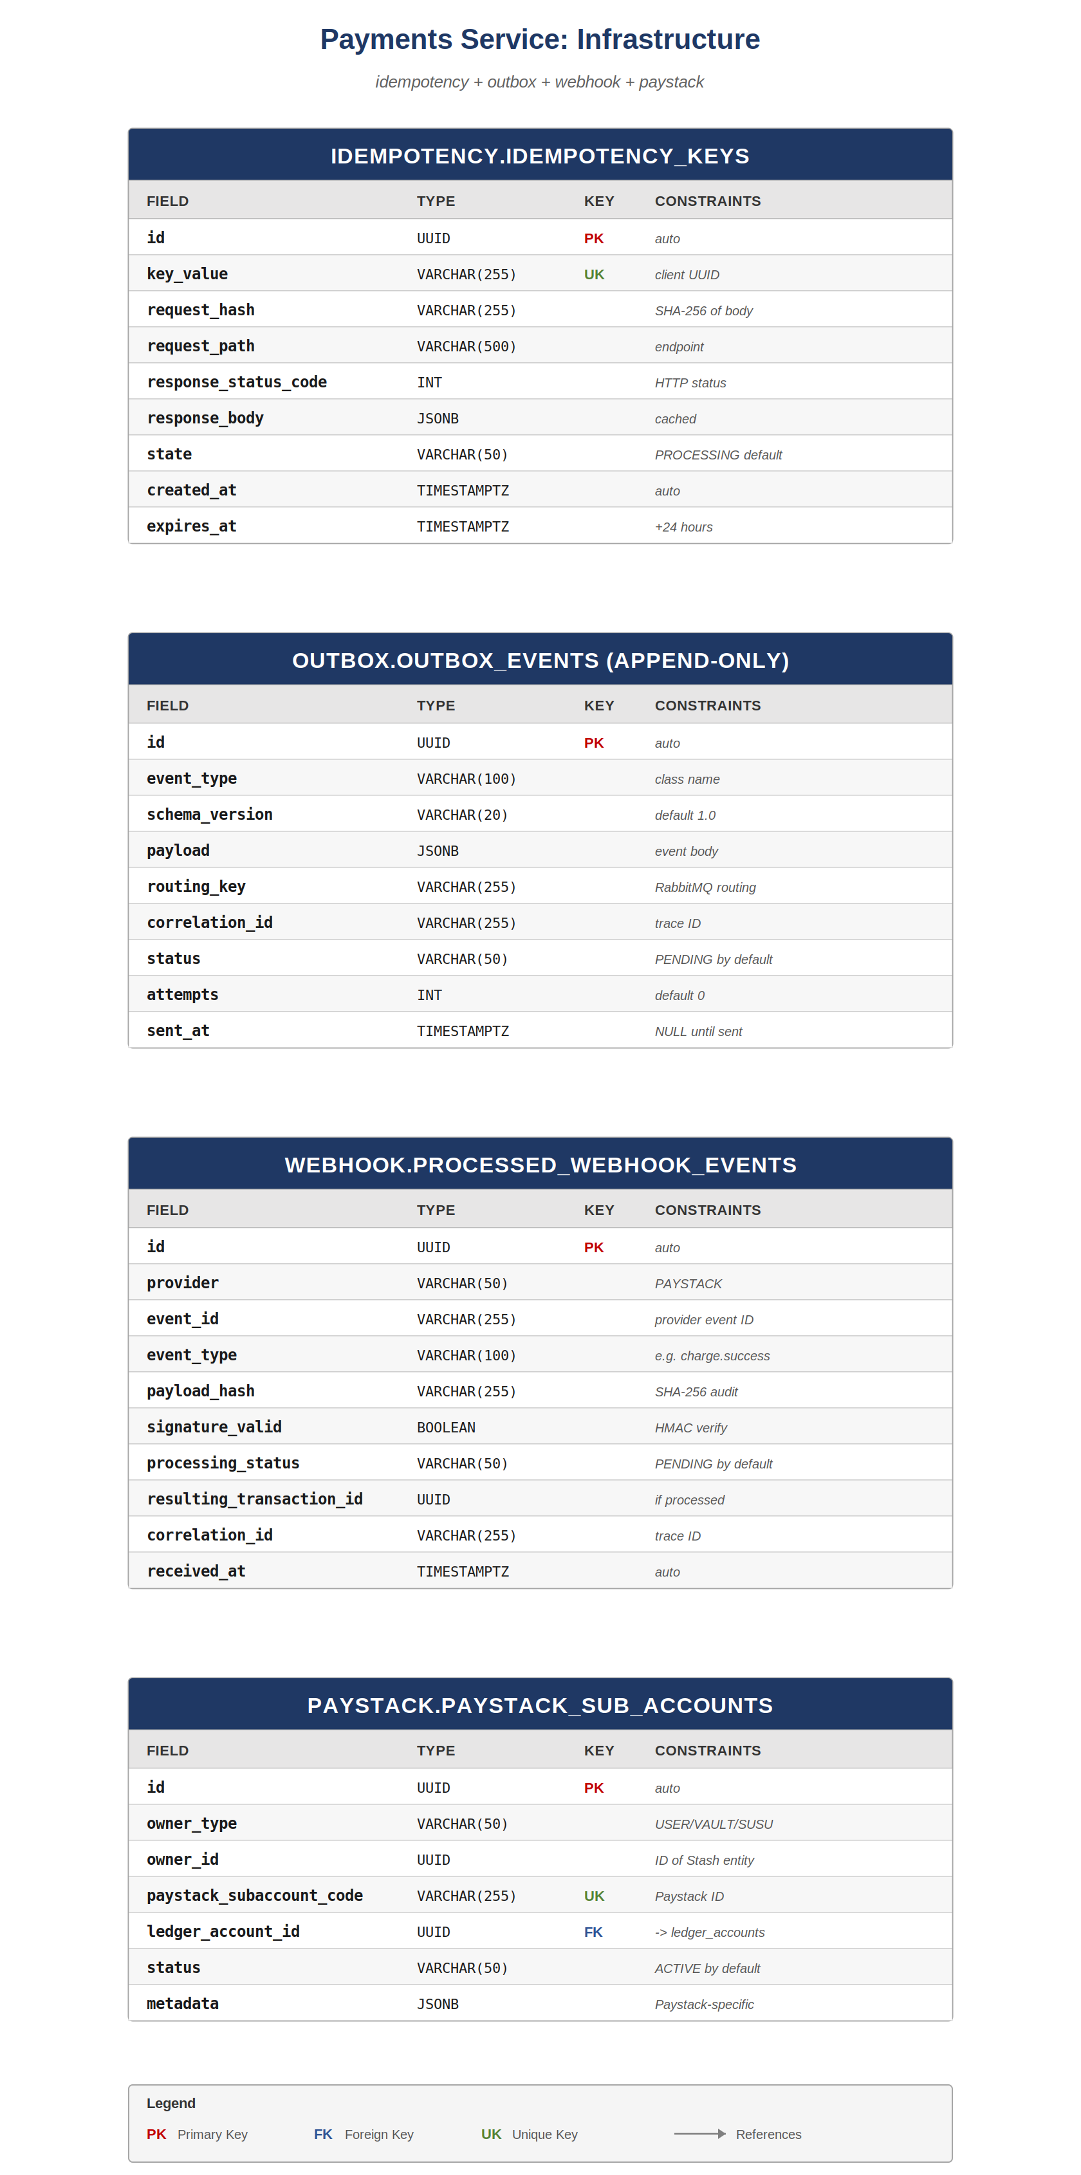

7.1 idempotency.idempotency_keys
Every mutating endpoint on the Payments Service requires the client to supply an Idempotency-Key header. On first request, a row is inserted in PROCESSING state; the request proceeds; on completion the response status and body are written back to the same row and state flips to COMPLETED. A retry with the same key inside the expiry window gets the cached response, not a second execution.
Field | Type | Key | Constraints
id | UUID | PK | auto
key_value | VARCHAR(255) | UK | The Idempotency-Key header value
request_hash | VARCHAR(255) |  | SHA-256 of method+path+body; detects key reuse with different body
request_path | VARCHAR(500) |  | Endpoint that owns this key
response_status_code | INT |  | Cached HTTP status
response_body | JSONB |  | Cached response body
state | VARCHAR(50) |  | PROCESSING/COMPLETED/FAILED
created_at | TIMESTAMPTZ |  | DEFAULT now()
expires_at | TIMESTAMPTZ |  | + 24 hours

Indexes
- (key_value) — covered by unique constraint.
- (expires_at) — for the cleanup job that removes old keys.
If request_hash mismatches
Same Idempotency-Key, different body = reject with 422. The client either deliberately or accidentally tried to reuse a key for a different operation. The error message tells them so explicitly; correct behaviour is to generate a fresh key per logical operation.

7.2 outbox.outbox_events (APPEND-ONLY)
The transactional outbox pattern. Whenever the Payments Service produces a domain event (DepositCompleted, TransferCompleted, SusuContributionCollected), it writes both the business change AND a row to outbox_events in the same database transaction. A separate background relay reads PENDING rows, publishes them to RabbitMQ, and marks them SENT. This guarantees that if the business change committed, the event will eventually be published — there is no window where the change exists but the event was lost to a crash.
Field | Type | Key | Constraints
id | UUID | PK | auto
event_type | VARCHAR(100) |  | Fully-qualified event class name
schema_version | VARCHAR(20) |  | DEFAULT '1.0'; bumped if payload shape changes
payload | JSONB |  | Event body
routing_key | VARCHAR(255) |  | RabbitMQ routing key
correlation_id | VARCHAR(255) |  | Trace ID across services
status | VARCHAR(50) |  | PENDING/SENT/FAILED
attempts | INT |  | DEFAULT 0; capped at 5
sent_at | TIMESTAMPTZ |  | NULL until published
created_at | TIMESTAMPTZ |  | DEFAULT now()

Append-only enforcement
INSERT and SELECT are granted to the application role. UPDATE is granted only on the sent_at and status columns — the relay needs to mark events as sent. (An alternative design forbids UPDATE entirely and uses a separate outbox_relay_state table; the team picked the simpler approach. The trade-off is recorded in ADR-0007.)

7.3 webhook.processed_webhook_events
Paystack will retry a webhook several times if our endpoint returns 5xx. The endpoint must therefore be idempotent. Each incoming webhook event is hashed against the event_id Paystack supplies; if we've seen it before (a row exists), we ack and ignore. If not, we insert in PENDING and process; once processed, we mark COMPLETED.
Field | Type | Key | Constraints
id | UUID | PK | auto
provider | VARCHAR(50) |  | PAYSTACK (currently only one)
event_id | VARCHAR(255) |  | Provider's event ID
event_type | VARCHAR(100) |  | e.g. charge.success, transfer.failed
payload_hash | VARCHAR(255) |  | SHA-256 of the raw payload (audit)
signature_valid | BOOLEAN |  | HMAC verification result
processing_status | VARCHAR(50) |  | PENDING/COMPLETED/FAILED/IGNORED
resulting_transaction_id | UUID |  | If processing produced a transaction
correlation_id | VARCHAR(255) |  | Trace ID
received_at | TIMESTAMPTZ |  | DEFAULT now()
processed_at | TIMESTAMPTZ |  | NULL until terminal

Constraint
- UNIQUE (provider, event_id) — the same provider event is processed at most once.

7.4 paystack.paystack_sub_accounts
Mapping rows that connect a Stash entity (user, vault, susu group) to a Paystack subaccount. Every USER_WALLET has one corresponding Paystack subaccount; some vaults and susus also have their own subaccounts depending on settlement strategy. This table is what lets us settle money to Paystack while keeping our ledger as the canonical record.
Field | Type | Key | Constraints
id | UUID | PK | auto
owner_type | VARCHAR(50) |  | USER/VAULT/SUSU_GROUP
owner_id | UUID |  | ID of the Stash entity
paystack_subaccount_code | VARCHAR(255) | UK | Paystack's identifier
ledger_account_id | UUID | FK | -> ledger.ledger_accounts.id
status | VARCHAR(50) |  | ACTIVE/SUSPENDED/CLOSED
metadata | JSONB |  | Paystack-specific (bank info, business name, etc.)
created_at | TIMESTAMPTZ |  | DEFAULT now()

8. KYC Service
The KYC Service is its own database because the data it holds — Ghana Card numbers, dates of birth, scanned document images — is the most sensitive in the entire platform. Isolating it lets us apply tighter access controls, separate backup policy, and stricter retention rules without forcing the same constraints on the rest of the system.
Three tables: kyc_submissions (the submission itself and its decision), kyc_documents (the uploaded images and their storage references), and kyc_deletion_attempts (the audit trail for deletion of those images, since failed deletions need a retry log).
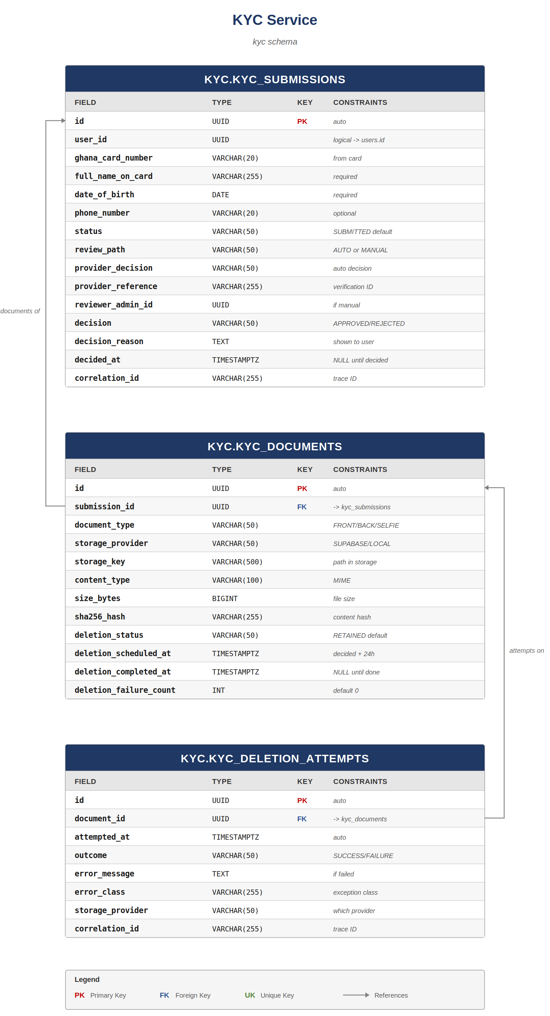

8.1 kyc.kyc_submissions
One row per submission attempt. A user can have multiple submissions over time (initial, resubmission after rejection, periodic re-verification). The review_path enum tracks whether this submission went the AUTO path (provider verified algorithmically) or the MANUAL path (escalated to a human reviewer). The user_id is a logical reference — the KYC Service does not have a foreign key to user_module.users because they live in different databases.
Field | Type | Key | Constraints
id | UUID | PK | auto
user_id | UUID |  | logical -> user_module.users.id
ghana_card_number | VARCHAR(20) |  | As entered by user (validated against card)
full_name_on_card | VARCHAR(255) |  | As shown on card
date_of_birth | DATE |  | Required
phone_number | VARCHAR(20) |  | Optional secondary check
status | VARCHAR(50) |  | SUBMITTED/REVIEWING/APPROVED/REJECTED/RESUBMISSION_REQUIRED
review_path | VARCHAR(50) |  | AUTO or MANUAL
provider_decision | VARCHAR(50) |  | Decision returned by KYC provider (if AUTO)
provider_reference | VARCHAR(255) |  | Provider's verification reference
reviewer_admin_id | UUID |  | logical -> admin_accounts.id; if MANUAL
decision | VARCHAR(50) |  | Final decision: APPROVED/REJECTED
decision_reason | TEXT |  | Shown to user (esp. for REJECTED)
submitted_at | TIMESTAMPTZ |  | DEFAULT now()
decided_at | TIMESTAMPTZ |  | NULL until decided
correlation_id | VARCHAR(255) |  | Trace ID

8.2 kyc.kyc_documents
The uploaded files (front of card, back of card, selfie). The image bytes themselves live in object storage (Supabase Storage); this row holds the reference. The deletion_status column drives a deferred-deletion state machine: RETAINED while the submission is being reviewed, PENDING_DELETION after the decision plus 24 hours of grace, then DELETED on successful deletion or DELETE_FAILED if storage was unreachable. A background retrier keeps trying DELETE_FAILED rows.
Field | Type | Key | Constraints
id | UUID | PK | auto
submission_id | UUID | FK | -> kyc_submissions.id
document_type | VARCHAR(50) |  | FRONT_OF_CARD/BACK_OF_CARD/SELFIE
storage_provider | VARCHAR(50) |  | SUPABASE/LOCAL (dev only)
storage_key | VARCHAR(500) |  | Path within the storage bucket
content_type | VARCHAR(100) |  | MIME type
size_bytes | BIGINT |  | File size
sha256_hash | VARCHAR(255) |  | Content hash; integrity check
deletion_status | VARCHAR(50) |  | RETAINED/PENDING_DELETION/DELETED/DELETE_FAILED
deletion_scheduled_at | TIMESTAMPTZ |  | decided_at + 24h
deletion_completed_at | TIMESTAMPTZ |  | NULL until DELETED
deletion_failure_count | INT |  | DEFAULT 0; retry budget
uploaded_at | TIMESTAMPTZ |  | DEFAULT now()

Indexes
- (submission_id, document_type) — fetch a submission's documents.
- (deletion_status, deletion_scheduled_at) WHERE deletion_status IN ('PENDING_DELETION','DELETE_FAILED') — for the deletion worker.
Why deferred deletion?
If a reviewer realises minutes after approval that the wrong submission was approved, having the documents still in storage allows quick correction. The 24-hour grace gives that recovery window. After grace expires, documents are deleted; the row remains (with deletion_completed_at set) as the audit trail that the deletion happened. The audit trail is permanent; the bytes are not.

8.3 kyc.kyc_deletion_attempts
Every attempt — successful or failed — to delete a kyc_documents row's bytes from storage is recorded here. This is the audit trail that proves we tried, what went wrong, and when. If deletion_failure_count on a document reaches 5, the document is escalated to ops for manual investigation.
Field | Type | Key | Constraints
id | UUID | PK | auto
document_id | UUID | FK | -> kyc_documents.id
attempted_at | TIMESTAMPTZ |  | DEFAULT now()
outcome | VARCHAR(50) |  | SUCCESS/FAILURE
error_message | TEXT |  | If FAILURE; the error returned by storage
error_class | VARCHAR(255) |  | Exception class name
storage_provider | VARCHAR(50) |  | Which provider was attempted
correlation_id | VARCHAR(255) |  | Trace ID

9. Audit Log Service
The Audit Log Service is the slowest-changing, most-trusted service in the platform. Every significant action across every other service publishes an event to RabbitMQ; the Audit Log Service consumes those events and writes them to its append-only log. Why a separate service? Two reasons. First, isolation of trust: the audit log must not be tamperable by the services it is auditing. Even an admin with full database access to the monolith cannot UPDATE or DELETE rows in the audit service's database (different credentials, different network policy). Second, scale: the audit log will grow much faster than any other table in the system, and isolating it lets us apply different storage tiers, archival policies, and retention rules.
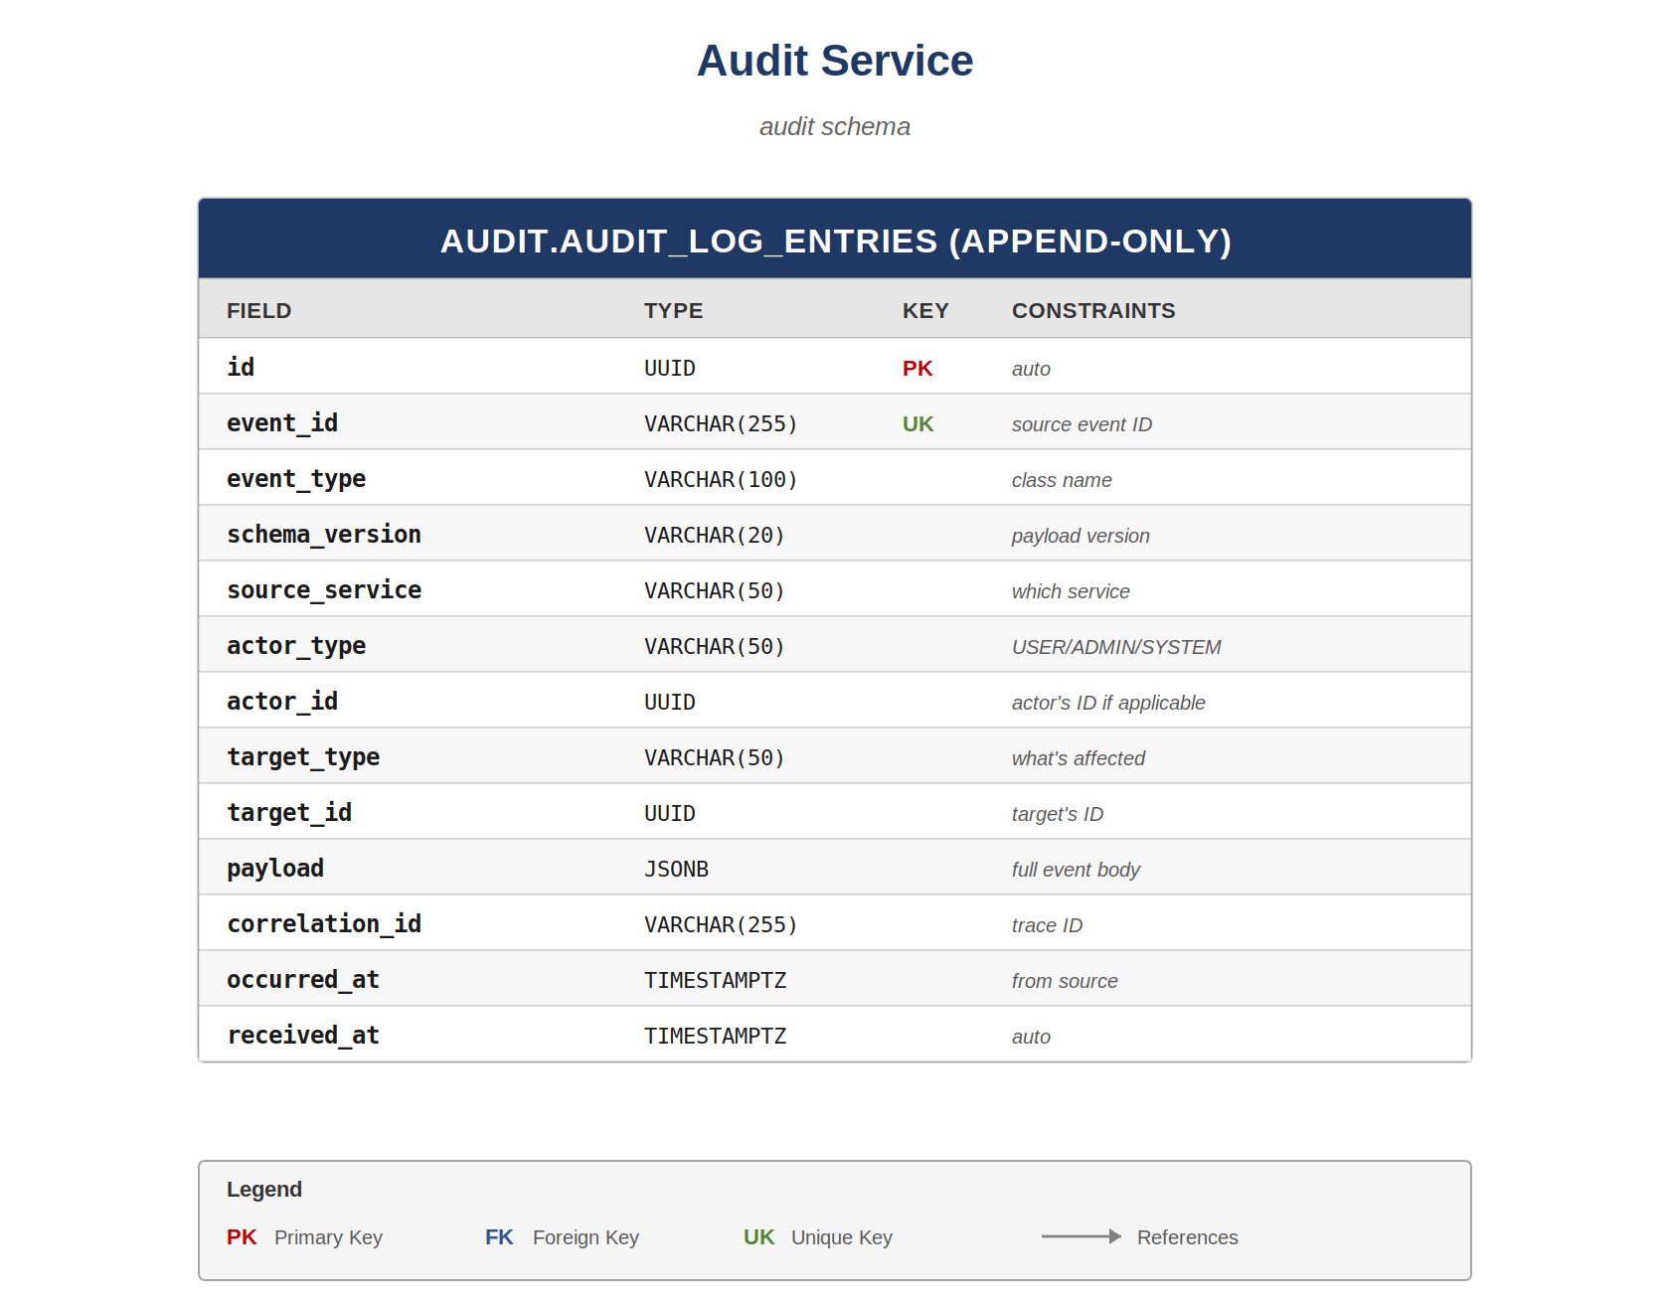

9.1 audit.audit_log_entries
One row per audited event. The structured columns capture the canonical 'who did what to what when' shape; the payload JSONB carries the event-specific extras (e.g. before/after state, dispute resolution reason, KYC documents involved). INSERT-only at the database role level. Even a SELECT is restricted to the audit dashboard service account; the application services that produce events have no SELECT either, only INSERT through the consumer.
Field | Type | Key | Constraints
id | UUID | PK | auto
event_id | VARCHAR(255) | UK | Originating event's ID (deduplication)
event_type | VARCHAR(100) |  | Fully-qualified event class name
schema_version | VARCHAR(20) |  | Schema version of the payload
source_service | VARCHAR(50) |  | Which service emitted this (monolith/payments/kyc)
actor_type | VARCHAR(50) |  | USER/ADMIN/SYSTEM/PROVIDER
actor_id | UUID |  | Actor's ID if applicable; NULL for SYSTEM
target_type | VARCHAR(50) |  | What was affected (USER, VAULT, SUSU_GROUP, ...)
target_id | UUID |  | Target's ID
payload | JSONB |  | Full event body, retained verbatim
correlation_id | VARCHAR(255) |  | Trace ID linking related events
occurred_at | TIMESTAMPTZ |  | When the event happened (from source)
received_at | TIMESTAMPTZ |  | DEFAULT now(); when audit service received it

Indexes
- (target_type, target_id, occurred_at DESC) — 'show me the history of this vault'.
- (actor_id, occurred_at DESC) — 'what has this admin done?'.
- (event_type, occurred_at DESC) — 'all KYC approvals last month'.
- (correlation_id) — trace a request across services.
- (received_at) — operational queries on lag between occurred and received.
Why JSONB for the payload?
Different event types have completely different shapes — a KYC approval has a documents array; a transfer has sender/recipient/amount. Storing all of that as flat columns would mean either dozens of mostly-NULL columns or constant schema changes. JSONB gives us schema-on-read flexibility while still allowing GIN indexes on specific JSONB paths if we later need to query by them.

10. Worked Examples
Two worked examples follow. The first is a deposit flow — the simplest end-to-end operation in the system. The second is a complete susu group lifecycle from creation through the first round disbursement. Together they show how the entities defined in earlier chapters interact when real business operations happen.
Read both end-to-end at least once before writing your first persistence-layer code. They are also useful reference material when debugging — if a real event happens in production and you need to trace what tables were affected, these examples show the canonical sequence.

10.1 Akua deposits GHS 100 into her STANDARD vault
Akua is an existing user with verified KYC, a USER_WALLET ledger account, and a STANDARD vault named 'Laptop Fund' with its own VAULT ledger account. The vault currently holds GHS 0. She opens the Stash app, selects her vault, taps 'Deposit', enters GHS 100, and confirms with MoMo through Paystack.

Step 1 — Mobile app initiates the deposit
The mobile app generates a fresh idempotency key (a UUID) and a correlation ID. It POSTs to /api/v1/vaults/{vaultId}/deposits with body { amount: 10000, source: 'MOMO' } and headers Idempotency-Key and X-Correlation-Id.

Step 2 — Monolith creates pending transaction & calls Paystack
The Vault module receives the request, validates the vault is ACTIVE and owned by Akua, then calls the Payments Service's POST /api/v1/transactions/deposits passing the same idempotency key and correlation ID.
The Payments Service inserts into idempotency.idempotency_keys (state = PROCESSING, request_hash set). It then inserts into transaction.transactions a row with transaction_type = DEPOSIT, status = PENDING, gross_amount = 10000, fee_amount = 0, net_amount = 10000, external_provider = PAYSTACK. No ledger entries are written yet because Paystack hasn't confirmed the charge.
Payments Service calls the Paystack API to initiate a charge for 10000 pesewas on Akua's MoMo number. Paystack returns an authorization URL or initiation reference; Payments stores the reference and returns 202 Accepted to the monolith with the transaction reference (STSH-202605-XXXXXX).

Step 3 — Akua approves on her phone
She approves the MoMo charge in her telecom's app. Paystack processes the charge and, on success, sends a webhook POST to our /api/v1/webhooks/paystack endpoint with event_id, event_type = charge.success, and the payload referencing our transaction's external reference.

Step 4 — Webhook handling
The Payments Service webhook handler verifies the HMAC signature. It inserts into webhook.processed_webhook_events with the provider event_id and a UNIQUE constraint that protects against Paystack retrying. If the unique constraint fails (duplicate event_id), the handler returns 200 immediately — idempotent webhook processing.
If this is a new event, processing_status is set to PENDING, and the handler proceeds to the ledger write.

Step 5 — Ledger write (the money actually moves on our books)
Within a single database transaction, the Payments Service inserts:
- One ledger.ledger_transactions row (transaction_type = DEPOSIT, amount = 10000, business_reference = the transaction.id).
- Two ledger.ledger_entries rows:
- — DEBIT 10000 against the PAYSTACK_SETTLEMENT account (money came in from Paystack).
- — CREDIT 10000 to Akua's VAULT account for 'Laptop Fund' (money is now in her vault).
- One outbox.outbox_events row with event_type = DepositCompleted, payload containing vault_id, user_id, amount.
- Updates transaction.transactions: status = COMPLETED, completed_at = now(), ledger_transaction_id set.
- Updates webhook.processed_webhook_events: processing_status = COMPLETED, processed_at = now(), resulting_transaction_id set.
- Updates idempotency.idempotency_keys: state = COMPLETED, response cached.
All eight writes commit atomically. Double-entry invariant holds: 10000 debit + (-10000) credit = 0.

Step 6 — Event propagation
The outbox relay picks up the PENDING outbox event in its next poll, publishes it to RabbitMQ with routing key payments.deposit.completed, and marks the row SENT.
Three consumers receive the event:
- The Audit Log Service consumer inserts audit.audit_log_entries: event_type = DepositCompleted, actor = Akua, target = the vault, payload = the full event body.
- The Notification module in the monolith inserts notification.notifications: type = DEPOSIT_SUCCESS, channel = PUSH, title = 'Deposit successful', body containing the amount.
- The Challenge module checks if Akua has any active SAVE_AMOUNT challenges and updates their progress_amount.

Step 7 — Notification delivery
The notification worker reads PENDING rows, fetches Akua's active device_tokens, and dispatches push notifications via the Expo Push API. delivery_status flips to DELIVERED on success.

Tables written to (total: 9)
1. | transaction.transactions (insert, then update)
2. | idempotency.idempotency_keys (insert, then update)
3. | webhook.processed_webhook_events (insert, then update)
4. | ledger.ledger_transactions (insert)
5. | ledger.ledger_entries (two inserts)
6. | outbox.outbox_events (insert, then sent_at update)
7. | audit.audit_log_entries (insert)
8. | notification.notifications (insert, then status update)
9. | challenge.user_challenges (update if applicable)

10.2 A six-member susu from creation to first payout
Akua organises a susu with five friends: GHS 200/month contribution, monthly frequency, six members total (her plus five). Below is the sequence of database writes from creation through the first round disbursement.

Stage 1 — Group creation (PENDING)
Akua taps 'Create Susu', fills in name, contribution amount, frequency, and target member count = 6.
- Insert susu.susu_groups: status = PENDING, current_round_number = NULL, join_code generated.
- Insert susu.susu_memberships for Akua: rotation_position = NULL (not yet assigned), status = ACTIVE.
- Outbox event SusuGroupCreated -> audit log.

Stage 2 — Members join (still PENDING)
Each friend opens the app, enters the join_code, and joins. Each join is one row in susu_memberships with rotation_position still NULL. After five joins (total six memberships), the target_member_count is reached.

Stage 3 — Activation
Akua taps 'Activate'. The application validates target_member_count is met and that all members are KYC-verified.
- Update susu_groups: status = ACTIVE, current_round_number = 1, start_date = today.
- Update all six susu_memberships: rotation_position assigned 1..6 in join order (Akua = 1).
- Insert six susu_rounds rows: one per member, round_number 1..6, recipient_user_id = member at that rotation_position, status = PENDING, scheduled_collection_at and expected_pot_amount filled in.
- Update susu_rounds: round 1 status -> COLLECTING (since current round is 1).
- Insert six susu_contributions for round 1: one per member, expected_amount = 20000 pesewas, status = PENDING.
- Outbox events: SusuActivated, SusuRoundStarted -> audit log + notifications.

Stage 4 — First-round collection
Over the next few days, each member's contribution flows from their USER_WALLET to the susu group's SUSU_POT ledger account.
For each member's contribution:
- Ledger transaction: DEBIT 20000 from member's USER_WALLET, CREDIT 20000 to SUSU_POT.
- Transaction record: type = SUSU_CONTRIBUTION, gross_amount = 20000.
- Update susu_contributions: status = PAID, collected_amount = 20000, transaction_id set.
- Outbox event SusuContributionCollected -> audit log + notifications to all members.
After all six contributions clear, susu_rounds row for round 1 has actual_pot_amount = 120000 (six × 20000), status flips to DISBURSING.

Stage 5 — Disbursement to recipient (Akua, rotation_position = 1)
One ledger transaction moves the entire pot from SUSU_POT to Akua's USER_WALLET:
- DEBIT 120000 from SUSU_POT.
- CREDIT 120000 to Akua's USER_WALLET.
- Insert transaction record: type = SUSU_DISBURSEMENT, gross_amount = 120000.
- Update susu_rounds: status = DISBURSED, disbursed_at set, disbursement_transaction_id set.
- Update susu_groups: current_round_number = 2 (advance to next round).
- Update next susu_rounds row (round 2): status COLLECTING.
- Insert six susu_contributions for round 2 (PENDING).
- Outbox events: SusuRoundDisbursed, SusuRoundStarted -> audit log + notifications.

Recap
Round 1 lifecycle generated roughly 14 ledger entries (12 for contributions + 2 for disbursement) and 20+ audit log entries. The susu_groups row was updated 3 times; the susu_rounds table holds the round state machine; susu_contributions tracks per-member-per-round payment state.

11. Schema Evolution
This document describes the schema as it stands at v1.0, with v1.5 and v2.0 additions marked in their respective chapters. Schema changes after v1.0 follow a strict process to prevent the chaos of ad-hoc migrations:
- Every schema change is a Flyway migration file in the relevant service's resources/db/migration directory.
- Every schema change updates this document in the same PR. A PR that adds a column without updating the table in this doc gets rejected at review.
- Significant changes (new tables, new schemas, new cross-service references) require an ADR (Architecture Decision Record) under docs/adr/.
- Index changes (new indexes, dropped indexes) require a brief note in the migration file explaining why; large indexes are added CONCURRENTLY in a separate migration to avoid blocking.
- Destructive changes (DROP COLUMN, DROP TABLE) are two-step: first a deprecation period where the column is NOT NULL removed and reads stop using it, then the drop migration.
The append-only tables (ledger_entries, outbox_events, audit_log_entries) cannot be changed in their core columns ever. Adding columns is fine; renaming or removing is not — the audit value of an append-only table depends on stability of meaning across all historical rows.

— End of Document —
Stash | Database Schema Design | Revision 2.0
Companion to: Stash Overall Product Document, Stash Phases and Versions

